Contents
II. WARNING 1
III. Introduction 1
IV. Main Specifications 2
V. Component Names 2
VI. Installation Instructions 3
VII. Good Information to Know: 4
VIII. LIMITED WARRANTY 5

WARNING
This instrument is a precision optical device. To ensure its service life and proper daily maintenance, the following measures must be taken:
Before using this instrument, please read this user manual carefully.
• Do not use or store the instrument in environments with prolonged exposure to high temperatures, humidity, or dust accumulation.
• Recommended operating temperature: 5°C to 35°C
• Relative humidity: 20% to 80% (at 25°C)
Note: Do not immerse this instrument in water or solvents.
Note: Do not place accessories not provided by the company into the frame or other transmission component.

Introduction
The ACCU-fluor ST Fluorescence Accessory utilizes long-life LEDs as its light source, effortlessly transforming a conventional microscope with an infinity optical system into an energy-efficient, user-friendly, and highly durable LED fluorescence microscope that enhances fluorescence observation without compromising visual field clarity. The ACCU-fluor ST is compatible not only with Micro-shot microscopes but also with other manufacturers' equipment.

Main Specifications
Type | Wavelength | Ex | BS | EM
B | 470-475nm | 460/30nm | 495nm | 520/40nm
G | 530-535nm | 530/40nm | 565nm | 605/55nm
Y | 560-600nm | 560/40nm | 600nm | 610nmLP
V | 395-400nm | 375/28nm | 415nm | 460/50nm


Component Names
7. Upper dovetail groove fixing screw


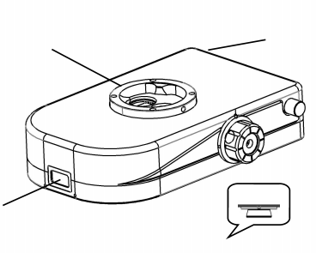
4. LED and filter block switching knob

3. Lower dovetail groove
2. Digital display screen
1. Upper dovetail groove
6. DC Interface
5. Switches and
Brightness Adjustment Button

Function Description:
Label 1: The position for fixing the observation tube;
Label 2: Displays the ACCU-SCOPE name along with channel names and brightness percentages;
Label 3: Designated for securing the fluorescence module to the microscope main unit;
Label 4: Allows switching between B, G or Y, and V fluorescence filter blocks and switches on the appropriate LEDs;
Label 5: Press to turn the module on/off, rotate to adjust brightness;
Label 6: For powering the fluorescence module;
Label 7: The fixing screw that secures both the module and the microscope viewing head.

Installation Instructions
The ACCU-fluor ST module is compatible with most Galilean-design (a.k.a. parallel, common main objective or CMO design) microscopes and installs between the optical zoom body of the microscope and the viewing head.

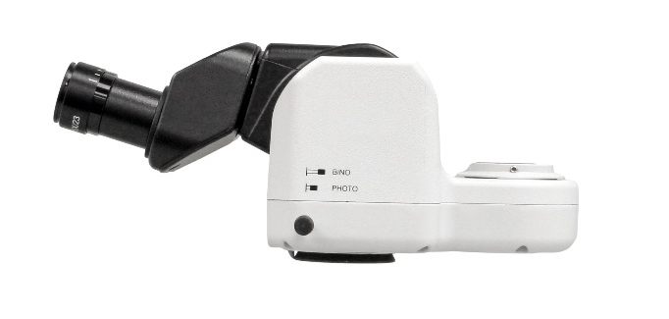

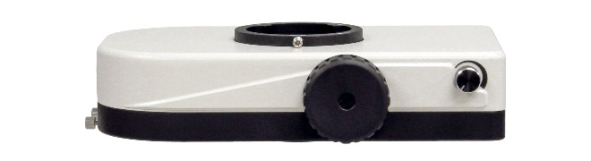

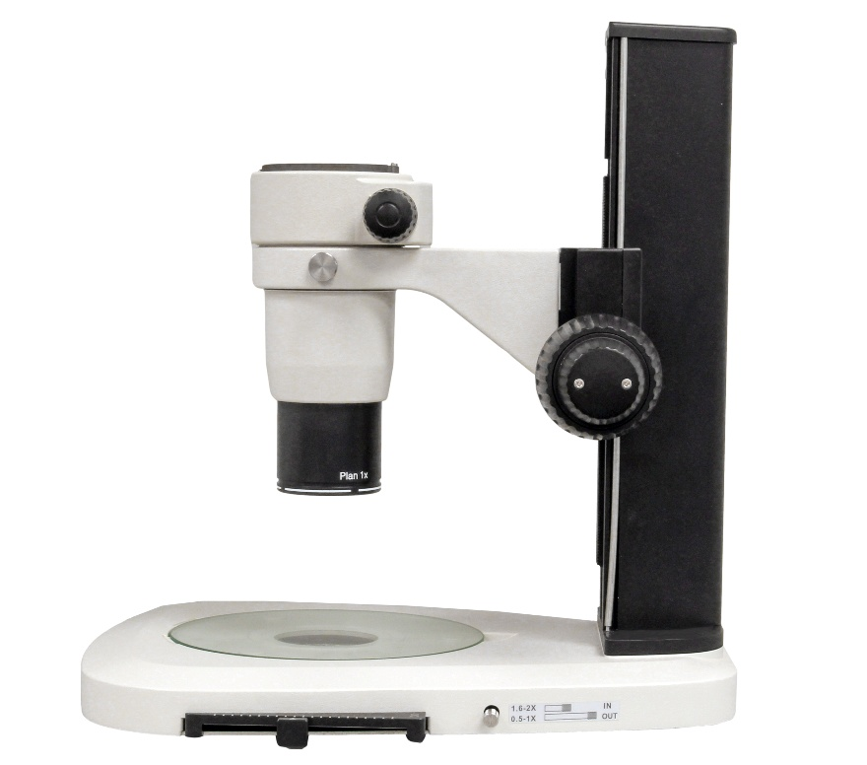
Installation and Operation Method:
- As shown in the photos above, loosen the viewing head fixing screw and remove the viewing head from the microscope body. For ease of installation, leave the rest of the microscope installed on the microscope stand (as shown).
- Install the fluorescence module onto the microscope optical body and tighten the fixing screw.
- Remove any shipping plug in the top of the fluorescence module. The plug prevents the filter block turret from damage during transportation. The plug must be removed before installing the fluorescence module on the microscope.
- Install the viewing head on top of the fluorescence module and tighten the fixing screw.
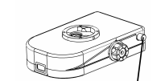
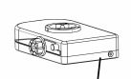
- Attach one end of the power cord to the power receptacle on the back of the fluorescence module and the other end with the AC adapter into an electrical receptable.

- Press the adjustment knob in towards the fluorescence module to turn on the module.
- Rotate the LED switching knob to the desired filter cube and LED position.

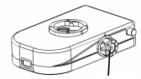
- Adjust the brightness using the adjustment knob (item 5 in the component diagram) to select an appropriate brightness level for observation. Note the LED channel and LED power setting (e.g., 50%) on the front display screen.

- As desired, rotate the LED switching knob to another position and repeat step 8.

Good Information to Know:
- The LED illumination intensity can be freely adjusted according to the need while observing the sample. Generally, it is recommended to operate the LEDs below 100% intensity to help extend the service life of the LED chip. When necessary, the brightness can be set to maximum.
- During fluorescence observation, the eyepiece must not be directly exposed to light sources or natural light; the sample plate mounted on the base should be non-reflective.
- It is recommended to place the specimen on a flat, black board or paper. Smooth white board transparent glass plates may create reflection, interfere with observation and, therefore, should not be used.
- During fluorescence observation, avoid prolonged light exposure to the sample to prevent fluorescence quenching/bleaching of the sample. Adjust the brightness as needed during observation periods.
- Turn off the power switch completely when not in use.
- During live observation without fluorescence, set the excitation block to “E” position and then turn off the fluorescence module power.
- During installation, ensure the fluorescence module is fully seated and flat against the microscope optical zoom body, otherwise, it may affect light uniformity in the sample.
- This power supply must strictly use the provided and dedicated 12V/2A adapter. Customers using other adapters may cause equipment damage and shall assume full responsibility for resulting damage to the fluorescence module.

LIMITED WARRANTY
This illuminator, the LED lamp and its electronic components are warranted to be free from defects in material and workmanship for a period of one year from the date of invoice to the original (end user) purchaser. This warranty does not cover damage caused in-transit, misuse, neglect, abuse or damage resulting from improper servicing or modification by other then ACCU-SCOPE approved service personnel. This warranty does not cover any routine maintenance work or any other work, which is reasonably expected to be performed by the purchaser. Normal wear is excluded from this warranty. No responsibility is assumed for unsatisfactory operating performance due to environmental conditions such as humidity, dust, corrosive chemicals, deposition of oil or other foreign matter, spillage or other conditions beyond the control of ACCU-SCOPE INC. This warranty expressly excludes any liability by ACCU-SCOPE INC. for consequential loss or damage on any grounds, such as (but not limited to) the non-availability to the End User of the product(s) under warranty or the need to repair work processes. Should any defect in material, workmanship or electronic component occur under this warranty contact your ACCU-SCOPE distributor or ACCU-SCOPE at (631) 864-1000. This warranty is limited to the continental United States of America. All items returned for warranty repair must be sent freight prepaid and insured to ACCU-SCOPE INC., 73 Mall Drive, Commack, NY 11725 – USA. All warranty repairs will be returned freight prepaid to any destination within the continental United States of America, for all foreign warranty repairs return freight charges are the responsibility of the individual/company who returned the merchandise for repair.

